**Assignment 2**

**Steps to create an EC2 instance on AWS**

Step 1 – Go to EC2 dashboard by searching “EC2” on the main console home

Step 2 – Click on launch instance on the EC2 dashboard

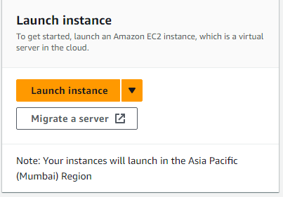

Step 3 – Give the name of the instance

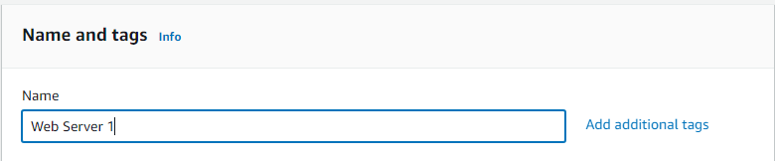

Step 4 – Select OS (Ubuntu recommended) and Amazon Machine Image

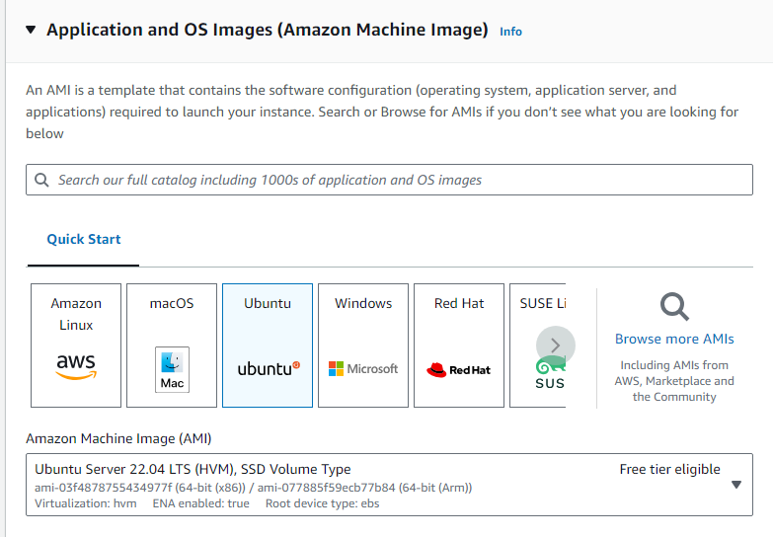

Step 5 – Select the instance type

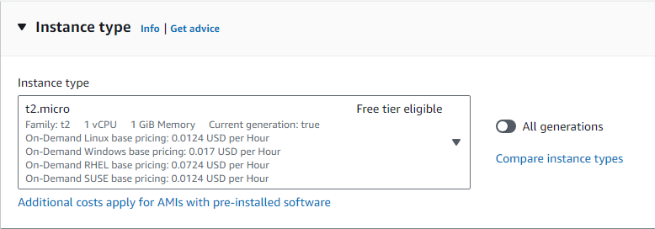

Step 6 – Click on “create a new key pair” and give a key pair name, select RSA as the key pair type, select .pem as the private file format and click on “create key pair” to download the .pem file.

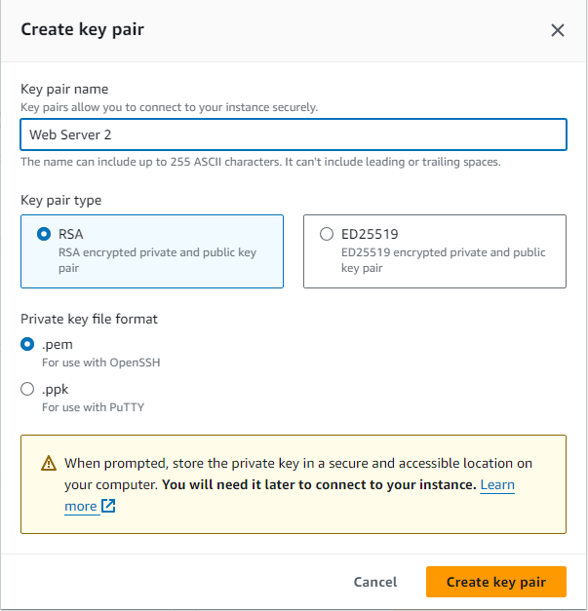

Step 7 – Scroll down to configure storage and select Magnetic(standard) root volume

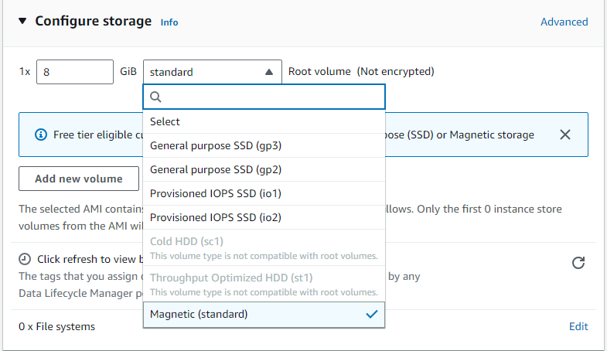

Step 8 – Finally click on “Launch instance” to launch the instance

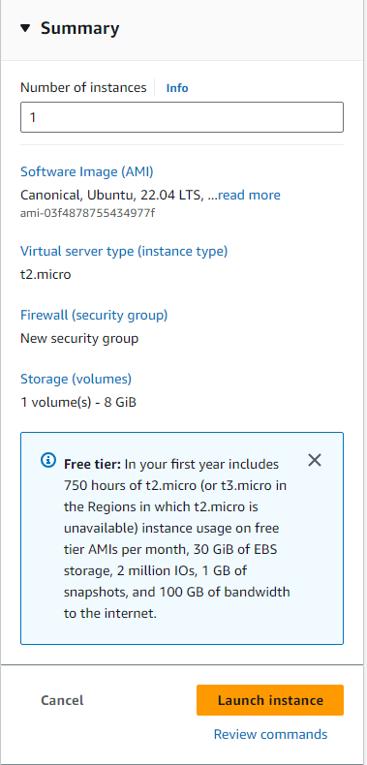

All instances can be seen in the instances tab on the EC2 dashboard.